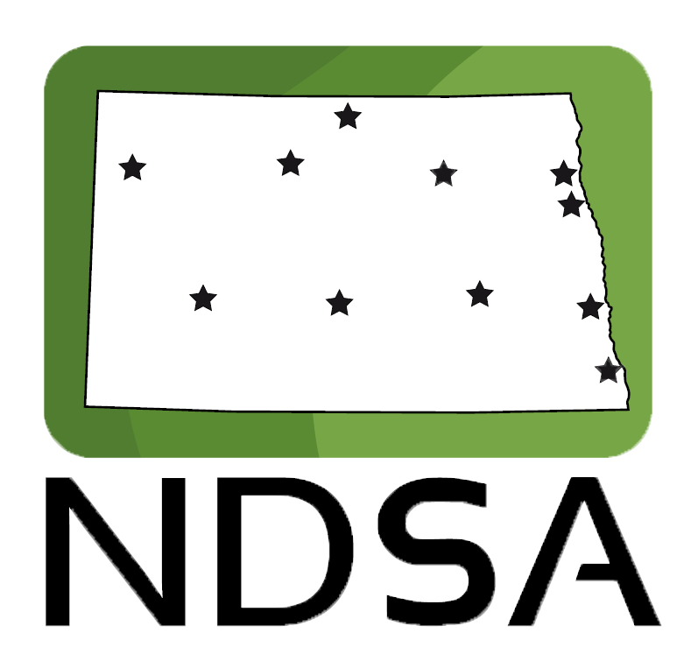

Minot state University

November 22nd-23rd, 2024

Version 3

**“The Voice of the Students”**

General Assembly

**Table of Contents**

**General Assembly Agenda – Friday ..........................................................................3**

**Internal affairs committee Agenda ......................................................................5**

**Student Affairs Committee Agenda .....................................................................7**

**State Legislative Affairs Committee Agenda ...............................................9**

**General Assembly Agenda – Saturday ................................................................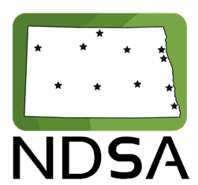11**

**General Assembly**

Agenda & Meeting Materials

(Friday)

Chaired by **Sammi Weber**, President

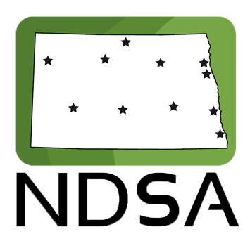

|  |  |  |
| --- | --- | --- |
| **5:05 PM** | [GA Teams Link](https://teams.microsoft.com/l/meetup-join/19%3ameeting_ZTMwMDI1ZDktNjcwYS00N2YwLTlmYjgtMTRiMWE1NDFkYWVk%40thread.v2/0?context=%7b%22Tid%22%3a%22ec37a091-b9a6-47e5-98d0-903d4a419203%22%2c%22Oid%22%3a%227479518c-ebb3-4cb1-9579-fcd6807dc646%22%7d)   1. Welcome Address |  |
| **5:10**  **5:25** | 1. Guest Speakers 2. Preview of Committees and Breakout Sessions |  |
| **5:30** | 1. Announcements |  |
| **5:40** | 1. Breakout Sessions |  |
| **6:00** | 1. Break to Committees |  |

**Internal Affairs Committee**

Agenda & Meeting Materials

Chaired by **Hayden Larson**, Vice President of Finance and Operations



[IAC Teams Link](https://teams.microsoft.com/l/meetup-join/19%3ameeting_MTI3ZGQyMDQtZjc1MS00OTFlLTg2OTctOWEzOTNmMGM0NDY4%40thread.v2/0?context=%7b%22Tid%22%3a%22ec37a091-b9a6-47e5-98d0-903d4a419203%22%2c%22Oid%22%3a%222d7b3b62-3591-42d0-b22d-c6ee10284523%22%7d)

1. Committee Activity
2. Call to Order
3. Roll Call
4. Explanation of Meeting Procedure
5. How to Join the NDSA Office 365 SharePoint
6. Approval of and Additions to the Agenda
7. Officer Reports
   1. Vice President of Finance and Operations, Hayden Larson
   2. Director Report, Dylan Campbell
8. Open Forum for Student Concerns  
   *Delegates shall discuss the statewide issues affecting students at their campuses.*
9. Order of Business:
   1. Host school Reimbursement
   2. Promotional items/plan
   3. Budget
   4. Strategic plan
   5. Quorum
   6. Archive/thesis
   7. Bylaws update – people who can attend NDSA
10. Announcements and Comments
11. Adjourn

**Student Affairs Committee**

Agenda & Meeting Materials

Chaired by **Jayden Erickson**, Vice President of Communication



[SAC Teams Link](https://teams.microsoft.com/l/meetup-join/19%3ameeting_ZGNkM2E1ZmMtNDRmYS00MDU0LTljZjgtZjYzMDY5N2E3YjNl%40thread.v2/0?context=%7b%22Tid%22%3a%22ec37a091-b9a6-47e5-98d0-903d4a419203%22%2c%22Oid%22%3a%22008fc4f5-db37-42ff-a0d5-a0e9743f5158%22%7d)

1. Committee Activity
2. Call to Order
3. Roll Call
4. Explanation of Meeting Procedure
5. How to Join the NDSA Office 365 SharePoint
6. Additions to and Approval of the Agenda
7. Officer Reports:
   1. Vice President of Communication, Jayden Erickson
   2. Director of Public Relations, Madeleine Phillips
8. Open Forum for Student Concerns  
   *Delegates shall discuss the statewide issues affecting students at their campuses.*
9. Order of Business:
   * 1. Food Pantry Discussion
     2. Campus Safety Discussion
     3. Marketing Discussion
     4. Resolution in Support of Mental Health Task Forces Across All NDUS Campuses
     5. Director of Diversity and Inclusion
10. Announcements and Comments
11. Adjourn

**State Legislative  
Affairs Committee**

Agenda & Meeting Materials

Chaired by **Carter Gill**, Vice President of Governmental Affairs



[SLAC Teams Link](https://teams.microsoft.com/l/meetup-join/19%3ameeting_YWMxY2M1OTMtZDM4OS00ZDIzLWI2NGItYzU4NzkwYzMxZWYz%40thread.v2/0?context=%7b%22Tid%22%3a%22ec37a091-b9a6-47e5-98d0-903d4a419203%22%2c%22Oid%22%3a%22d39bdad4-05e6-4e8f-85d4-e2dd8cd0f273%22%7d)

1. Committee Activity
2. Call to Order
3. Roll Call
4. Explanation of Meeting Procedure
5. Video: How to Join the NDSA Office 365 SharePoint
6. Additions to and Approval of the Agenda
7. Officer Reports:
   1. Vice President of Governmental Affairs, Carter Gill
   2. Director of Governmental Affairs, Josh Hansen
   3. Director of Policy, Advocacy, and Research, Christopher Scott
8. Open Forum for Student Concerns  
   *Delegates shall discuss the statewide issues affecting students at their campuses.*
9. Order of Business: (Resolutions will be sent out with final agenda)
   1. Higher Education Day
   2. Resolution in Support of the North Dakota Challenge Fund Grant Program
   3. Discussion on two Voting Resolutions
      1. Resolution in Support of Changing ND Century Code to Allow Employees Time to Vote on Election Day
      2. Resolution in Support of Changing ND Century Code to Allow Out-of-State Students to Vote in ND Without Changing Residency
10. Announcements and Comments
11. Adjourn

General Assembly

Agenda and Meeting Materials

(Saturday)

****Chaired by **Sammi Weber**, President

|  |  |
| --- | --- |
| **9:05 AM** | [GA Teams Link](https://teams.microsoft.com/l/meetup-join/19%3ameeting_ZTMwMDI1ZDktNjcwYS00N2YwLTlmYjgtMTRiMWE1NDFkYWVk%40thread.v2/0?context=%7b%22Tid%22%3a%22ec37a091-b9a6-47e5-98d0-903d4a419203%22%2c%22Oid%22%3a%227479518c-ebb3-4cb1-9579-fcd6807dc646%22%7d)   1. Call to Order |
| **9:10** | 1. Roll Call |
|  | 1. Explanation of Meeting Procedure |
|  | 1. **ACTION: Additions to and Approval of the Agenda** |
|  | 1. **ACTION: Consider Approval of the Consent Agenda** *A consent agenda allows the General Assembly to approve routine and noncontentious agenda items and reports simultaneously in a single agenda item, saving time during the meeting. Items will be placed underneath this line item prior the start of Saturday’s meeting. Members may request to remove items from the consent agenda.* |
|  | * 1. Consider Approval of Minutes from Previous Meeting   2. Vouchers |
| **9:25** | 1. Committee Reports: |
|  | 1. Internal Affairs Committee |
|  | 1. Student Affairs Committee |
|  | 1. State Legislative Affairs Committee |
| **9:40** | 1. Presidential Report 2. SBHE Student Member Report |
| **9:45** | 1. New Business    1. Budget Presentation    2. A Resolution in Support of Mental Health Task Forces Across All NDUS Campuses    3. A Resolution in Support of Mandating Mental Health Training Programs for NDUS Faculty and Staff    4. A Resolution in Support of Increasing Duo Authentication Authorization Time from Three Hours to Two Weeks for Blackboard    5. A Resolution in Support of Multicultural Engagement Programming in the NDUS |
| **10:30** | 1. Complete General Assembly Feedback Survey |
|  | 1. Institutional Reports |
|  | 1. Public Comment and Announcements |
| **11:00** | 1. Adjourn |

|  |  |  |  |  |  |  |  |
| --- | --- | --- | --- | --- | --- | --- | --- |
| **INSTITUTION** | **STUDENT TOTAL** | **APPORTIONED VOTING DELEGATES** | | **DELEGATES PRESENT** | | **DELEGATES VOTING** | |
| **Bismarck State College** | 4,206 | 7 | |  | |  | |
| **Dakota College at Bottineau** | 1,206 | 4 | |  | |  | |
| **Dickinson State University** | 1,410 | 4 | |  | |  | |
| **Lake Region State College** | 1,897 | 5 | |  | |  | |
| **Mayville State University** | 1,134 | 4 | |  | |  | |
| **Minot State University** | 2,751 | 6 | |  | |  | |
| **North Dakota State College of Science** | 3,367 | 6 | |  | |  | |
| **North Dakota State University** | 11,952 | 15 | |  | |  | |
| **University of North Dakota** | 15,019 | 18 | |  | |  | |
| **Valley City State University** | 1,806 | 5 | |  | |  | |
| **Williston State College** | 1,058 | 4 | |  | |  | |
| **TOTAL:** | |  | |  | |

|  |  |  |  |  |  |
| --- | --- | --- | --- | --- | --- |
| **RULE** | **SECOND NEEDED** | **DEBATE / DISCUSSION** | **AMENDABLE** | **REQUIRED VOTE** | **DESCRIPTION** |
| **Point of Order** | No | No | No | None | Used to address a misuse of the rules or a personal affront. *May interrupt a speaker.* |
| **Point of Parliamentary Inquiry** | No | No | No | None | Used to gain clarification about a rule or procedure. *May interrupt a speaker.* |
| **Point of Information** | No | No | No | None | Ask a question of a speaker in control of the floor. |
| **Recess** | Yes | No | Yes | Simple Majority | Recess the meeting for a specified period of time. |
| **Table a Motion** | Yes | Yes | Yes | Simple Majority | Postpone consideration of a business item until a future meeting. |
| **Previous Question** | Yes | Yes | No | Two-Thirds Majority | End debate on a proposal and bring it to an *immediate* vote. |
| **Open a Speaker’s List** | Yes | No | No | Simple Majority | Used to create a list for delegates wishing to speak. Speakers will then indicate to the Chair or their appointee if they want to be added to the list. |
| **Limits on Debate** | Yes | Yes | Yes | Two-Thirds Majority | Impose (or repeal) a limit on the length of any form of debate. Limits may be specified in terms of time or number of speeches. |
| **Suspension of the Rules** | Yes | No | No | Two-Thirds Majority | Used to allow the General Assembly to violate its own rules, except for rules specified in the Constitution. The object of suspension must be specified. |
| **Division of the Question** | Yes | Yes | No | Simple Majority | Divide a resolution or report into two or more clauses/sections, each to be voted on separately. This motion is used after the passage of Closure of Debate. |
| **Reconsideration of a Motion** | Yes | Yes | No | Two-Thirds Majority | Reconsider an item on which debate has ended or upon which a vote has taken place. |
| **Appeal a Decision of the Chair** | Yes | Yes | No | Simple Majority | Challenge a ruling made by the Chair. *May interrupt a speaker.* |

***Final approval of any NDSA resolution requires the affirmation of at least 60% of the General Assembly.***